Information about GANs(Generative Adversarial Networks )

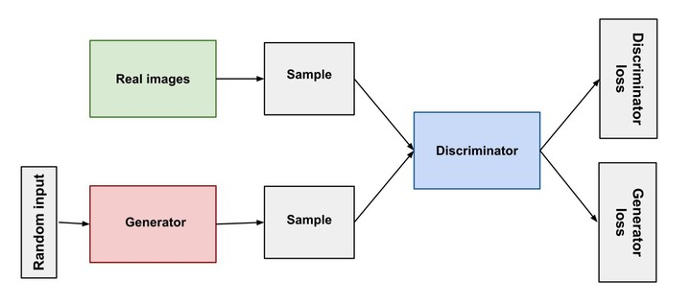

Image Source: <https://www.maskaravivek.com/post/gan-synthetic-data-generation/>

Main Steps:

1). The generator network takes a random input and tries to generate a sample of data.

2). The discriminator is trained upon the original dataset, it learns to recognize the values from original dataset.

3). The sample of generated data by generator is then fed to the discriminator.

4). The task of discriminator is to take input either from the real data or from the generator and try to predict whether the input is real or generated.

5). The discriminator then solves a binary classification problem using sigmoid function giving output in the range 0 to 1.

Parts of training GAN

Part1: Train discriminator and freeze generator (freeze means setting training as false. The network does only forward pass and no backpropagation is applied)

Part2: Train generator and freeze discriminator.

Source: <https://www.analyticsvidhya.com/blog/2017/06/introductory-generative-adversarial-networks-gans/>

<https://wiki.pathmind.com/generative-adversarial-network-gan>

Table Evaluator:

TableEvaluator is a library to evaluate how similar a synthesized dataset is to a real data. In other words, it tries to give an indication into how real your fake data is. With the rise of GANs, specifically designed for tabular data, many applications are becoming possibilities. For industries like finance, healthcare and goverments, having the capacity to create high quality synthetic data that does **not** have the privacy constraints of normal data is extremely valuable.

Source: https://github.com/Baukebrenninkmeijer/table-evaluator